Media Contact:
Name
Phone Number
Email
For Immediate Release
Date XX, XXXX

The True Story of Tomás and The Library Lady Celebrates the Power of Reading and Imagination

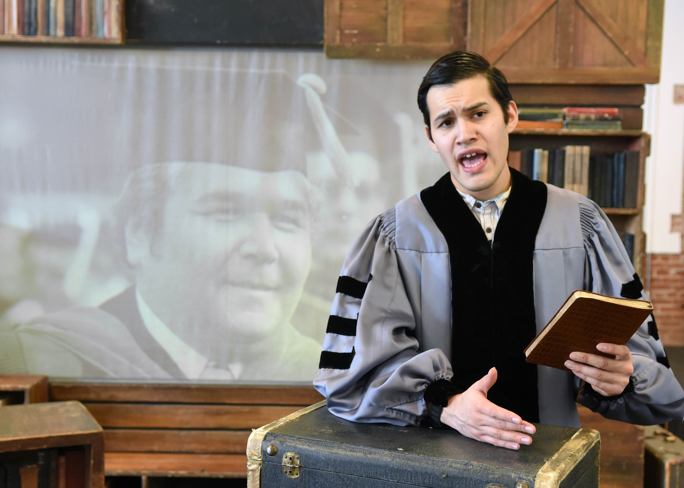

LOCATION
DATE RANGE

(LOCATION) Tomás and the Library Lady tells the true story of Tomás Rivera, a Chicano author, poet and educator who found an unlikely friend in a librarian when he was a young boy. Rivera’s empowering story inspired Pat Mora to write a book telling his story, which COMPANY NAME will bring to life for families at LOCATION DATE RANGE & PERFORMANCE INFORMATION.

Tomás, the son of migrant workers, was born in Texas and loves the stories Papa Grande tells to him. One day while his family is in Iowa picking crops, Tomás meets the Library Lady and nothing is ever the same again. Soon his imagination takes off as he reads book after book, discovering a world filled with dinosaurs, tigers, and explorers! Childsplay brings back this bilingual play with music for a brand new audience.

“I believe that Tomás and the Library Lady is an empowering story for young people because it speaks about following your dreams, about using your imagination, the power of reading books, and making new friends,” said Playwright José Cruz González who wrote the play in partnership with Childsplay Theatre in Tempe, Ariz.

Tickets start at $XX and are on sale now at WEBSITE or at LOCATION Box Office PHONE NUMBER. The play is recommended for ages 5 and up. LOCATION is located ADDRESS.

While creating the play, González researched the life of Tomás Rivera, contacted his widow and brother and even visited the Tomás Rivera Library at the University of California at Riverside.

“As I dug into the story of the real Tomás Rivera, I found so much to add into the adaptation,” said González.

Since Childsplay Theatre premiered the play in 2006, this show has embarked on four statewide tours throughout Arizona and three national tours.

Director: David Saar
Costume & Scenic Design: Holly Windingstad
Lighting Design: Kara Ramlow
Music Director: Tommy Strawser
Sound & Media Design: Anthony Runfola
Stage Manager: Ellen Beckett

Tomás and the Library Lady was written by José Cruz González, based on the book by Pat Mora.

For interviews, media appearances or high-resolution images, please contact NAME at PHONE NUMBER or EMAIL.

About Childsplay:
Childsplay, Inc. is a nonprofit theatre company of professional, adult artists who perform for and teach young audiences and their families. The mission of Childsplay is "to create theatre so strikingly original in form, content or both, that it instills in young people an enduring awe, love and respect for the medium, thus preserving imagination and wonder, the hallmarks of childhood which are keys to the future." For more information, visit www.childsplayaz.org.
####

